PERSONAL PORTFOLIO WEBSITE DEVELOPMENT
INTERNSHIP PROJECT-1
DOCUMENTATION REPORT

Submitted By :
Name: Anuprabha .D Register Number: 6176AC23UCS011 Department: Computer Science And Engineering College: Adhiyamaan College of Engineering
1. PROJECT OVERVIEW
The Personal Portfolio Website is a web-based application developed using HTML and CSS. The primary purpose of this project is to create an online platform where personal information, educational background, technical skills, certifications, projects, and contact details can be presented professionally.
In today's digital world, a portfolio website serves as an online resume and personal branding tool. It allows recruiters, employers, mentors, and other professionals to understand an individual's capabilities and achievements through a well-organized interface.
The project was developed using HTML and CSS, which helped in understanding the fundamentals of frontend web development. The website consists of multiple sections, including Home, About, Education, Skills, Projects, Certifications, Resume, and Contact. Each section is carefully designed to provide specific information while maintaining a consistent and visually appealing user interface.
This project demonstrates the practical implementation of front-end web development concepts. The website consists of multiple sections including Home, About, Education, Skills, Projects, Certifications, Resume, and Contact. Each section is designed to provide specific information while maintaining a consistent visual appearance.
The project also helped in understanding website deployment using GitHub Pages, version control using GitHub, and project organization using proper folder structures. The completed website is accessible online and can be viewed from any device with internet access.

2. OBJECTIVES
The main objectives of this project are:
🔹 Technical Objectives
- To understand the fundamentals of web development
- To gain hands-on experience in HTML and CSS
- To learn how to structure a complete website
- To implement responsive design techniques
- To improve coding and debugging skills

🔹 Educational Objectives
- To apply theoretical knowledge into a practical project
- To understand real-world project development workflow
- To learn file organization and project structuring
🔹 Career Objectives
- To build a strong personal brand online
- To create a portfolio for job opportunities
- To present skills and projects in a professional manner
- To increase confidence in front-end development
🔹 Practical Objectives
- To design a clean and user-friendly interface
- To ensure mobile and desktop compatibility
- To deploy the website on a hosting platform
- To understand version control using GitHub

🛠️ 3. TECHNOLOGIES USED
🔷 HTML5 (HyperText Markup Language)
HTML is the backbone of the website. It is used to define the structure and layout of the web pages. All content such as headings, paragraphs, images, and links are created using HTML tags.
🔷 CSS3 (Cascading Style Sheets)
CSS is used to enhance the appearance of the website. It controls layout, colors, fonts, spacing, animations, and responsiveness. CSS makes the website visually appealing and professional.
🔷 JavaScript
JavaScript is used to add interactivity such as:
- Navigation menu toggle
- Smooth scrolling
- Form validation
- Button animations
🔷 VS Code
Visual Studio Code is used as the primary code editor. It provides features like syntax highlighting, extensions, and live server preview.
🔷 Git & GitHub
Git is used for tracking changes in the project, while GitHub is used for storing and hosting the project online.
🔷 Deployment Platforms
- GitHub Pages
- Netlify
- Vercel
These platforms help make the website publicly accessible.

🌐 4. WEBSITE FEATURES
The portfolio website includes the following features:
🏠 Home Section
- Introduction of the developer
- Welcome message
- Attractive layout with profile image
👤 About Section
- Personal details
- Educational background
- Career goals
💡 Skills Section
- Programming languages
- Web technologies
- Technical strengths
📂 Projects Section
- List of developed projects
- Short descriptions
- Links to GitHub repositories
📞 Contact Section
- Email address
- Social media links
- Contact form
📱 Additional Features
- Responsive design
- Smooth navigation
- Clean UI/UX design
- Organized layout
- Fast loading performance

5.SCREENSHOTS
Home Page:
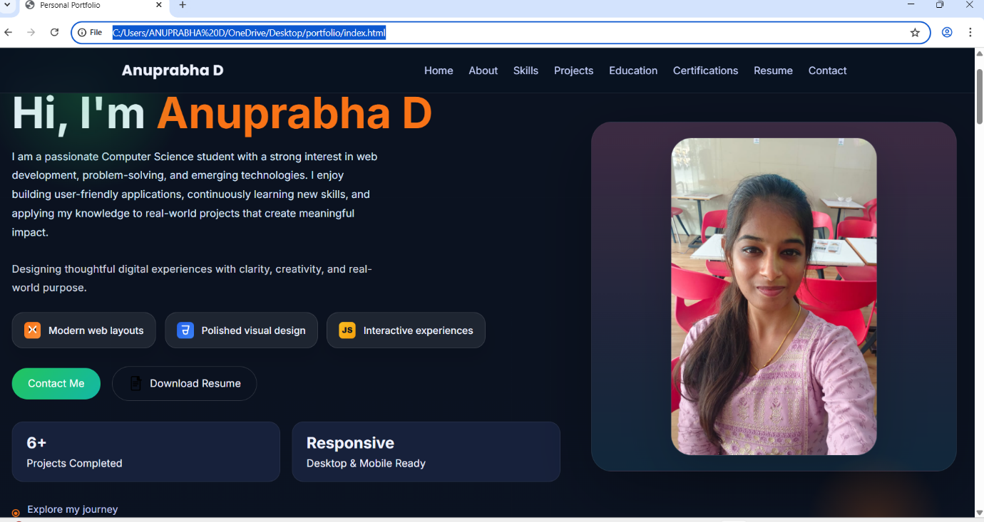
About Section:
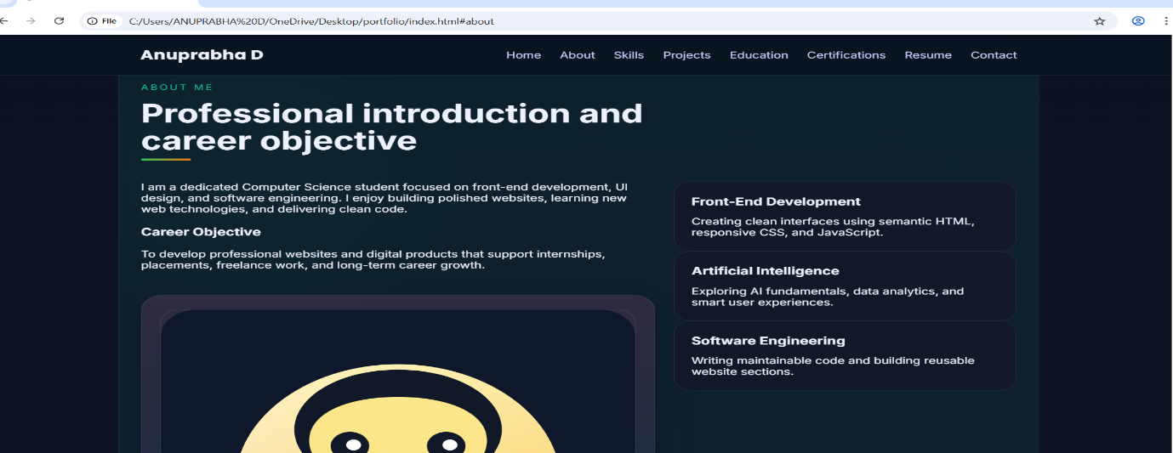

Skills Section:
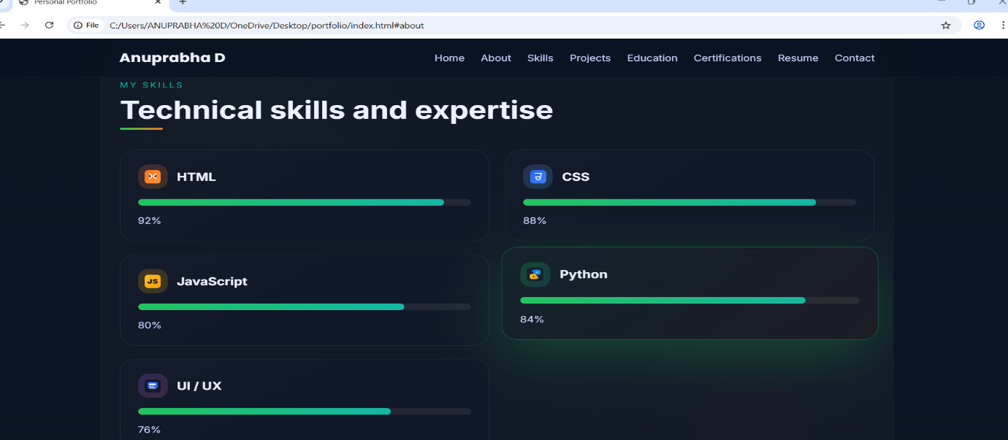
Project Section:
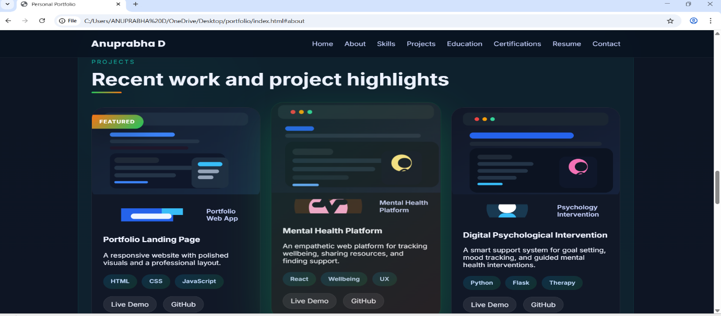
Education Section:
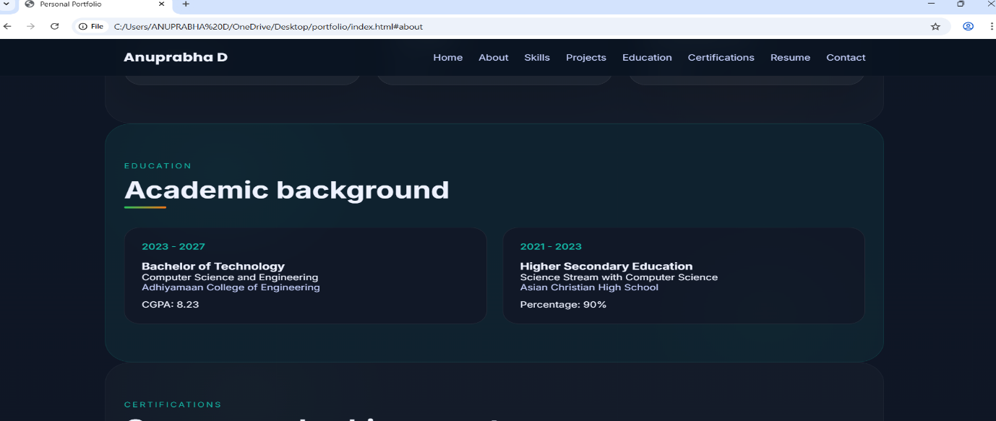
Certificate Section:
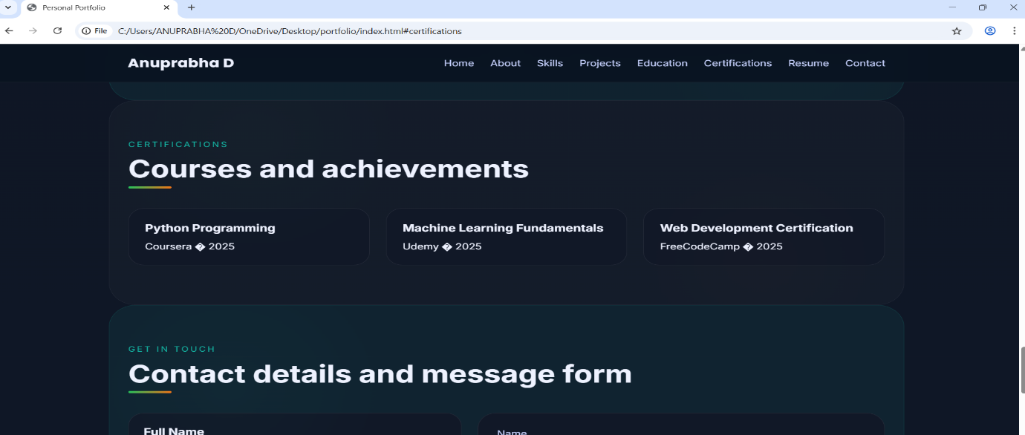
Contact Page:
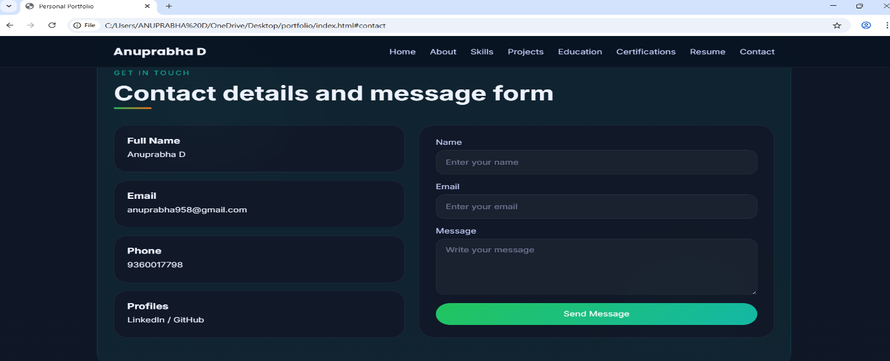

📁 6. FOLDER STRUCTURE
Portfolio-project/
│
├──index.html
├──about.html
├──style.css
├──script.js
│
├──images/
│├──profile.jpg
│├──project1.png
│
├──assets/
└── README.md
📌 Importance of Structure:
- Helps in easy navigation
- Makes debugging easier
- Keeps files organized
- Supports scalability
- Improves collaboration

🧑‍💻 7. DEVELOPMENT PROCESS
Step 1: Requirement Analysis
- Identified project requirements
- Selected features and sections
Step 2: Wireframe Design
- Created basic layout idea
- Decided structure of each section
Step 3: HTML Development
- Built webpage structure
- Added text, images, and links

Step 4: CSS Styling
- Applied colors and fonts
- Designed layout using Flexbox/Grid
- Improved UI design
Step 5: Responsive Design
- Added media queries
- Adjusted layout for mobile devices
Step 6: Testing
- Tested in multiple browsers
- Fixed alignment issues
- Corrected image paths
Step 7: Deployment
- Uploaded project to GitHub
- Enabled GitHub Pages
- Verified live website link

⚠️ 8. CHALLENGES FACED
- Difficulty in aligning elements using CSS
- Understanding Flexbox and Grid layout
- Making website fully responsive
- Deployment errors in GitHub Pages
- Image loading issues
- Browser compatibility issues

✅ 9. SOLUTIONS IMPLEMENTED
- Used Flexbox for alignment
- Applied media queries for responsiveness
- Organized folder structure properly
- Verified file paths carefully
- Used developer tools for debugging
- Followed GitHub deployment steps
- Tested multiple times before final submission

🚀 10. FUTURE ENHANCEMENTS
- Add backend support for contact form
- Convert into React-based portfolio
- Add dark mode feature
- Improve animations using JavaScript
- Add blog section
- Improve SEO optimization
- Add chatbot feature
- Add downloadable resume section
- Improve UI using frameworks like Bootstrap or Tailwind CSS

🏁 11. CONCLUSION
The Personal Portfolio Website project was a highly valuable learning experience that helped in understanding core web development concepts.
It provided practical exposure to designing and developing a complete website from scratch. Through this project, I improved my skills in HTML, CSS, layout design, responsiveness, and deployment.
This project also helped in developing problem-solving skills and understanding real-world development workflows. It serves as a strong foundation for future advanced web development projects.
Overall, this project successfully achieved all its objectives and enhanced both technical and creative skills.

Deployment link:
https://anu635.github.io/Portfolio-project1/

GitHub Repository:
https://github.com/ANU635/Portfolio-project1

